

Ashby Road  Daventry  NN11 0QF | T: 01327 702878  Falconer’s Hill Infant School  Prospectus 2026/27 | www.falconershillinfants.com  admin@fhis.inmat.org.uk

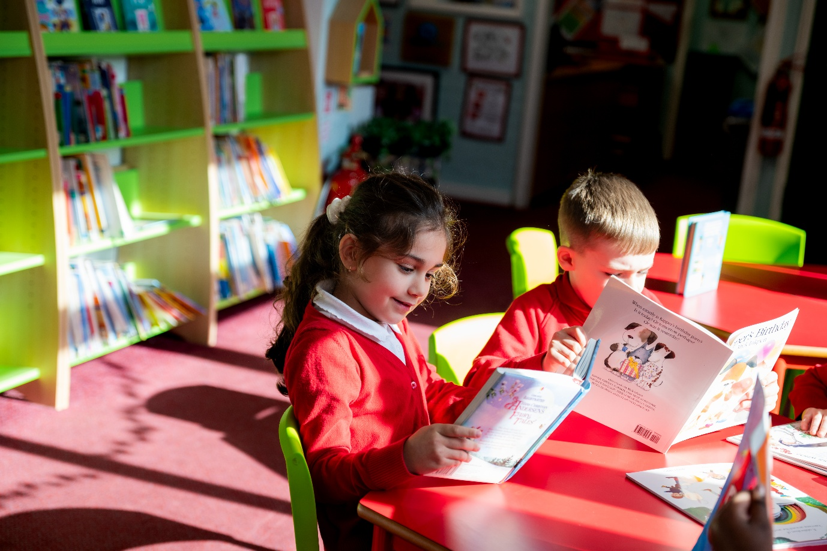
At Falconer’s Hill Infant school, everything we do has the children at the heart of it. Our passionate teaching team works hard to provide the children of Falconer’s Hill Infant school with an education of the highest quality.
As a Head Teacher, I have always been principled about learning. I am a learner, I love to learn and I am delighted to lead a school and staff team which is happy to explore new ideas and to continually develop our practice.

 | Meet the Team
 | Mrs Edkins:  Miss Giles:  Miss Clark:  Mrs Haynes:  Mr Little:  Miss Evans:  Miss Hall:  Mrs Wicks:  Mrs Waldock- Hanson:  Mrs Kenworthy:  Mrs Bowmer:  Mrs Britten:  Miss Doyle:  Mrs Galbraith:  Mrs Jones:  Mrs Lee:  Mrs Waker:  Mrs Wild:  Mrs Taylor:  Mrs Griffiths:  Mrs Orme:  Mrs Burton:  Mrs Howard:  Mrs Zambonini:  Mr Bungard: | Executive Head Teacher & Lead SENCo  Head of School, SENDCo & Safeguarding Lead  Class Teacher  Class Teacher  Class Teacher  Class Teacher  Class Teacher  Class Teacher  Class Teacher (Maternity Leave)  School Business Manager  HLTA  Teaching Assistant  HLTA  Teaching Assistant  Teaching Assistant  Teaching Assistant  Teaching Assistant  Teaching Assistant  Pupil Support Worker  Admin Officer/Attendance Officer  Admin Assistant  Behaviour and Nurture Lead & Breakfast Club Assistant  Breakfast Club Assistant/Cleaner  Lunchtime Supervisor  Site Supervisor
Message from the Executive Head Teacher  Falconer’s Hill Infant School, everything we do has the children at the heart of it. Our passionate teaching team works hard to provide the children of Falconer’s Hill Infant school with an education of the highest quality.  As a Head Teacher, I have always been principled about learning. I am a learner, I love to learn and I am delighted to lead a school and staff team which is happy to explore new ideas and to continually develop our practice.  The children and the families are the heart of FHIS and I believe they should all have the best opportunities to reach their full potential. I have a real love for learning and want to ensure we are providing creative and irresistible experiences across each and every day. Together, home and school can create a strong partnership which can engender and nurture that essential aspect of children’s education, a love for learning, which is why we actively encourage your involvement.  Do come and see what Falconer’s Hill Infant School has to offer your child. We can guarantee you a very warm welcome. |  |  | 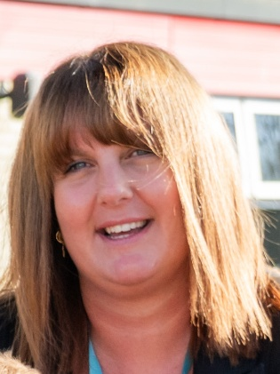  Rachel Edkins  Executive Head Teacher and Lead SENCo
Mrs R EdkinSafeguarding  Safety of children is our number one priority, from security of the site to the welfare of each individual. We have very clear guidelines in place to ensure that our safeguarding is robust. We ensure that all staff, volunteers and visitors have current DBS checks before working with children.  - The welfare of children and their wishes and feelings are afforded consideration when developing and carrying out school activities.  - All children have equal rights to support and protection irrespective of their race, age, ability, gender, language, religion, sexual orientation and culture.  - All staff and volunteers have a professional role to identify and respond to the needs of children and report any concerns immediately.  As a school, and in line with government statutory guidance we adhere to the ‘Keeping Children Safe in Education.’ Safeguarding children is everyone’s  responsibility and not something that we take lightly. You can read this guidance here:  https://www.gov.uk/government/publications/keeping-children-safe-in-education  Safeguarding is the action that is taken to promote the welfare of children and protect them from harm.  Safeguarding means: protecting children from abuse, maltreatment and preventing harm to their health or development.  Safeguarding is everyone’s responsibility.  Always remember – it could happen here | 
Safeguarding
Should you have any Safeguarding concerns,
please contact any of the staff below.

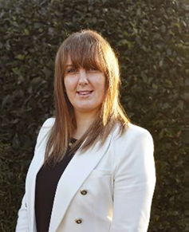
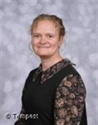
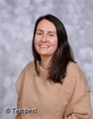


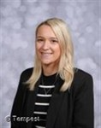
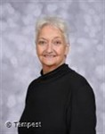
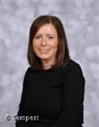
Rachel Edkins
Executive Headteacher
DSL

Phoebe Giles
Head of School, SENDCo & Safeguarding Lead Headteacher
DSL

Helen Wicks
Class Teacher
DSL

Abby Clark
Class Teacher
DSL

Russell Little
Class Teacher
DSL

Gemma Haynes
Class Teacher
DSL

Clare Griffiths
Admin Officer DSL Attendance
Teacher
DSL

Sue Burton
Behaviour & Nurture Lead DSL
Teacher
DSL

Maria Taylor
Pupil Support Worker
DSL
DSL

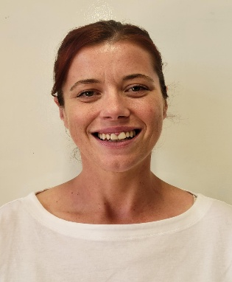

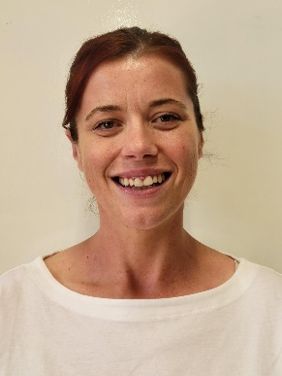
Learning Stars
We believe positive reinforcement encourages children to learn. We are also keen to promote good attitudes to learning.  It is important that children understand how they can become more effective learners ad we do this by encouraging them to develop the growth of their ‘learning stars’. At the beginning of every school year children find out about how their brain works and how important it is in helping them become ‘smart’.  Learning stars represent the skills the children are developing to become more effective learners. We spend time investigating each learning star so children are fully familiar with what they mean and they then achieve stars. For example, someone sitting attentively may be given a ‘listening’ learning star. |           
Celebration Assembly
Every Friday morning, we hold a Celebration Assembly. If your child has been awarded ‘Star of the Week’ you will be invited into school to attend the assembly – but please bear in mind it is a surprise and your child will not know
Breakfast Club
A school run breakfast club runs each day from 8.00am until 8.45am. Drop off for Club is through Mulberry.

It is staffed by our own staff, Mrs Howard and Mrs Burton.

The children get a good choice for breakfast which includes, cereal, toast, fruit, yoghurt and on a Friday a chocolate brioche may be spotted ! The children also have activities to keep them busy.

Cost is £4 per session and is payable through Arbor. If you are interested to book your child on, please contact the school office.

Afterschool Club
Our after-school care is provided by S4A and is available for children from 3:30 pm to 6:00 pm, Monday to Thursday, and from 3:30 pm to 4:30 pm on Fridays.

S4A provides a safe, caring, and engaging environment where children can take part in a range of activities after the school day.

Further information about booking and fees is available directly from S4A. www.s4aclub.co.uk

Attendance & Punctuality
Good attendance and punctuality helps the children settle in school and not miss out on vital learning and social experiences. Children with poor attendance can fall behind and catching up can be tricky. It is the parents responsibility to ensure that the is good attendance. The Attendance Team closely monitor attendance and will contact parents should they become concerned.  Children need to be in school every day unless ill or there are exceptional circumstances. We expect EVERY child to have a minimum attendance of 96%.  HOLIDAYS ARE NOT AUTHORISED IN TERM TIME – and can incur a fixed penalty fine issued by Northampton County Council Education Inclusion & Partnership Team. Schools have a duty to report any term-time absences of 5 consecutive days or 5 days unathorised absences over a 6 week rolling period. 3 or more days absent from school may result in a home visit.  Doors open at 8.45am so please be ready to come in at that time. Parents should bring their child to the classroom door and wait with them until the Teacher opens the door. Registers close at 8.55am. After that children will need to via the school office and receive a late mark.  School finishes at 3.20pm for EYFS and 3.25pm for Key Stage 1. Parents should collect from the classroom door. Please let the school office and the Class Teacher know if the usual person who picks up your child changes and/or the names of the other adults who are authorised to pick up your child. | 
Cont’d
If your child is ill, you must call the school office as soon as possible. You can contact the office by telephone, email or via Seesaw. Details are shown below. The school office is open from 8am to 4pm each day. You can leave a voicemail out of these hours.

Appointments for opticians, Doctors or dentists should wherever possible, be made outside of school hours. If this is not possible, please contact the school office with proof of the appointment.

School Lunches & Snack
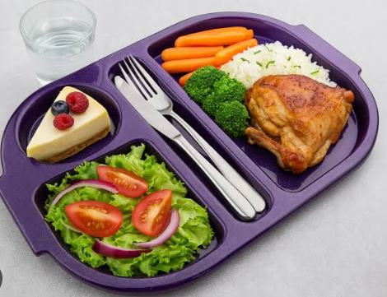
All children at Falconer’s Hill Infant school are entitled to a free school meal. We encourage all children to have a school dinner.

Dolce is our catering company who cook our school lunches. All food is freshly prepared in the Dolce pod and is healthy and nutritious. Lunches can be booked via School Grid – a welcome link will be sent to you once your child is enrolled with us. You can book each day, weekly or even termly, there is a choice of 2 hot lunches each day along with a jacket potato with a variety of fillings or even a sandwich if your child prefers. On the occasions where we have an event in school, your child may not be able to have the hot food option.

If your child does not wish to have school meal, they can of course bring in a nutritious healthy, packed lunch from home.

Allergies information needs to be provided by the parents to the Class Teacher and School office.

Children are offered a piece of fruit or a vegetable as well as water during the day.

Children that are under the age of 5 are entitled to free milk. Please see www.coolmilk.com to register.


Uniform
School uniform can be purchased from larger supermarket stores and uniform featuring our logo can be purchased from either Tailor Made Tel: 01327 311125 www.tailormade-online-co.uk or from School Trends www.schooltrends.co.uk.

Clothing disappears like magic in school so please label ALL your child’s clothing with either sew-in type labels or write-on labels – please regularly check that these have not washed off!

Please ensure that your child has their book bag every day as these are needed for books and phonics packs and any important information from school. These bags are the perfect size for fitting the school drawers. Your child will also need a water bottle every day.

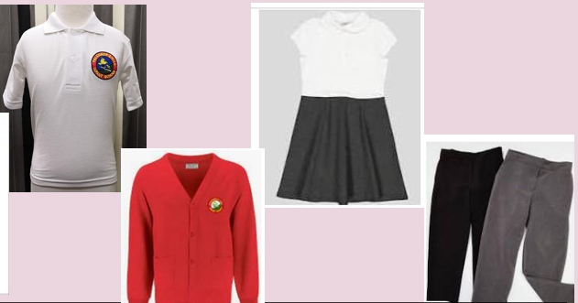
Jewellery should NOT be worn to school for health and safety reasons.


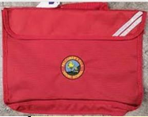

PE Days
PE is held twice per week per year group:

Timetable
EYFS : Wednesday and Friday
Year 1: Tuesday and Thursday
Year 2: Monday and Wednesday

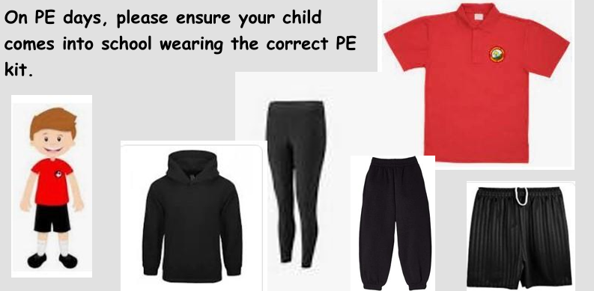

Times of the day
8.45am

Registration – classroom doors open at 8.45am. If you do arrive after 8.50am please bring your child to the school office.

9.55am – 10.05am

Breaktime for EYFS

10.45am – 11am

Breaktime for Key Stage 1

12 – 1 pm

EYFS Lunchtime

12.15 – 1.30 pm

Year 1 Lunchtime

12.30– 1.30 pm

Year 2 Lunchtime

3.20 pm

EYFS Hometime
Gates will be open from 3.00pm

3.25 pm
Key Stage 1 Hometime
Gates will be open from 3.15pm

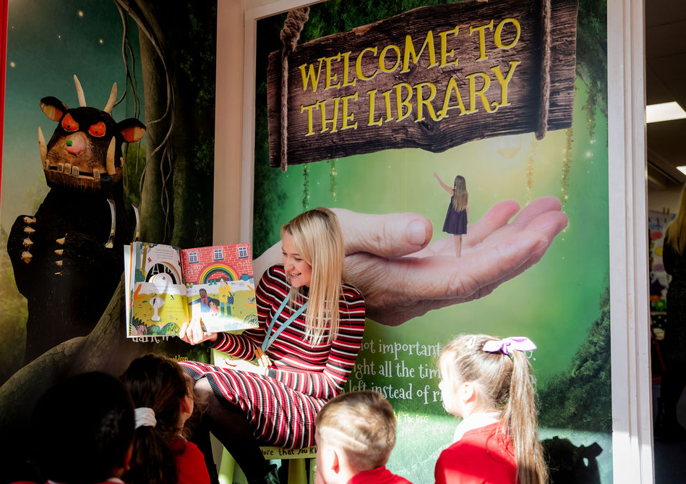
Ashby Road,
Daventry
Northamptonshire
NN11 0QF





www.falconershillinfants.co.uk

